**Instructions for COMSOL Modeling Project Part 2**

***Make sure you read all the instructions before you start (or else you will have to do a lot of backtracking and ultimately more work).***

1. Download the COMSOL instructions for this part and complete the step-by-step guide to modeling the dialysis fiber.

**Co-current flow**

Make the following changes:

* Add a line segment that runs the length of the fiber in the middle of the permeate layer (outer layer). (Note by adding the line segment some of the boundary numbers will change; be sure for the inlet and outlet conditions of the permeate for both physics that you select both boundaries that make up the inlet or outlet.)
* Change the length of the fiber from 21 mm to 40 mm.
* Create a new parameter for a flow ratio (you can pick a value of 1 to start).
* For inflow 2 (i.e., the inflow of permeate fluid), change average velocity to: (flow ratio)* (dialysate velocity). (Use the correct variable names)
* Run a parametric sweep using the flow ratios: 0.1, 0.2, 0.5, 0.75, 1, 2.
* Add a 1D plot with 2 line plots measuring concentration: 1 line plot for the center line of the dialysate (i.e., r=0); 1 line plot for the centerline of the permeate (the extra line segment you drew earlier). Use the parametric sweep solution.
* Add another 1D plot with 1 line plot measuring the “w-velocity z-component” (not velocity magnitude) at the top border (for all three layers: dialysate, membrane, and permeate). Use the parametric sweep solution.

**Counter-current flow**

1. Make the following changes and run the simulation again (be sure you collected all of the plots from the first simulation first).

* Change the outflow and outlet of the permeate from the top to the bottom border.
* Change the inflow and inlet of the permeate from the bottom to the top border.
* Do not change anything else; run the simulation again.

1. Write a short report that includes the following (be sure to provide a brief caption and comment for each figure):

**Co-current flow**

1. 2D surface plot of concentration with streamlines (total flux) and arrows (velocity magnitude). Use the scaled version that you made while following the instructions; just plot it for one parameter (ratio = 1).
2. 1D plot with the 2-line plots of centerline concentrations for all parameters (image for counter-current flow shown as an example).
3. 1D plot with line plot showing z-velocity in all three layers for all parameters.

**Counter-current flow**

1. 2D surface plot of concentration with streamlines (total flux) and arrows (velocity magnitude). Use the scaled version that you made while following the instructions; just plot it for one parameter (ratio = 1).
2. 1D plot with the 2-line plots of centerline concentrations for all parameters (image for counter-current flow shown as an example).
3. 1D plot with line plot showing z-velocity in all three layers for all parameters.
4. Concluding paragraph discussing how flow rates can affect mass transfer in a dialysis fiber. Also comment on the differences between a co-current and counter current flow set up; specifically comment on the maximum concentration in the permeate and minimum concentration in the dialysate for the two set ups (which one provides a unique advantage?.

Be sure to add appropriate titles, axes labels, legends, and units to your plots.

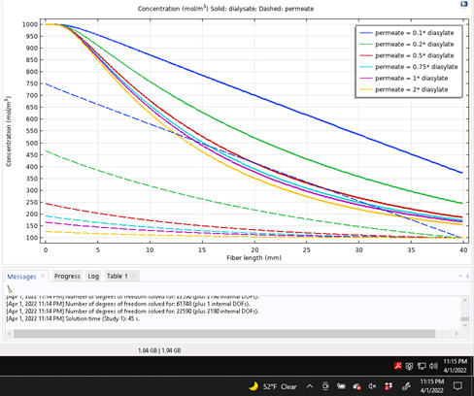

Centerline concentration for dialysate (solid) and permeate (dashed) for various flow ratios (dialysate average velocity = 0.5 m/s).